CMSC 678 Project 3
Paul Hudgins
Department of Computer Science
Virginia Commonwealth University
Richmond, VA, USA

Abstract—This report details the author's methods and results for CMSC 678 Project 3. A two-layer neural network was evaluated using a single split of a cancer data set. Performance comparisons were made for the number of iterations and number of hidden layer neurons.
Keywords-Neural network, Matlab,

Running the Project
Code for Part 1 can be executed by running hudgins_project3.m. A total of 28 training periods will be executed, so execution may take several minutes
- Training data, boundaries, and support vectors for Part 1.
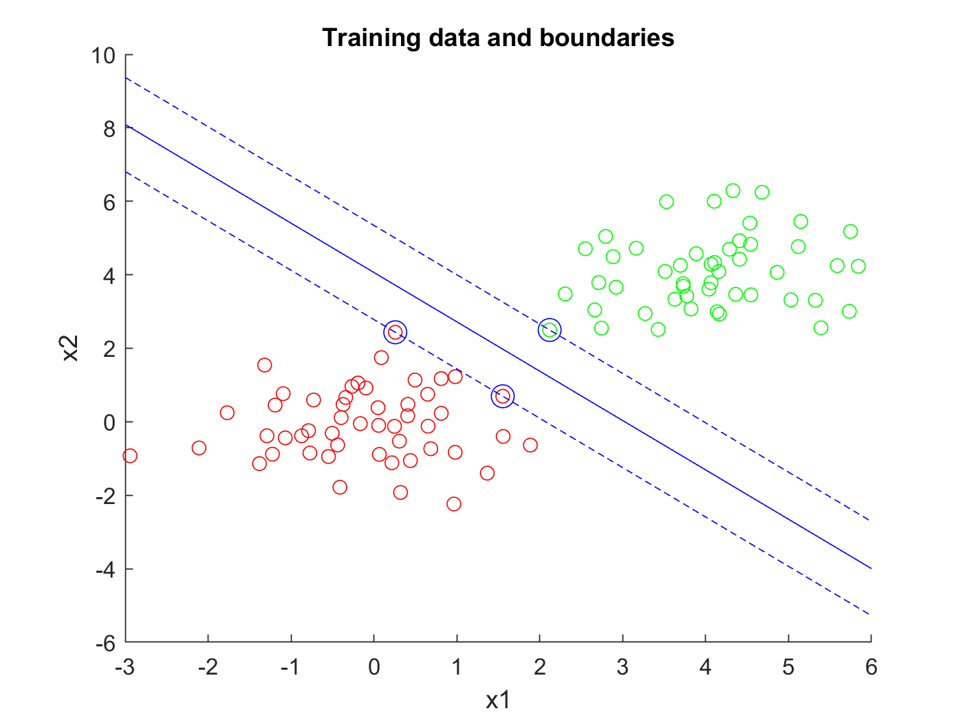

Methods

Neural Network Design
A two-layer neural network was developed in Matlab based on the methods described in [1]. Hyperbolic tangent was used as the activation function for hidden layer neurons.

Dataset and Experimental Setup
Training data consisted 198 examples of two-dimensional cancer-related data, divided into two classes. Neural networks were evaluated on a 75-25 split of this data. Evaluation was performed for four different numbers of iterations: 100, 250, 500, and 1000. For each of these, evaluations were performed for the following numbers of hidden neurons: 5, 10, 15, 25, 50, 75, 100.

Results

Neural network design

References
- V. Kecman, 'Multilayer Perceptron ie Neural Network', Virginia Commonwealth University, 2018
I

